**FINAL PRACTICAL**

Oregon Tech

MIS 240: Linux Fundamentals

Ethan Dunzer

8/12/20

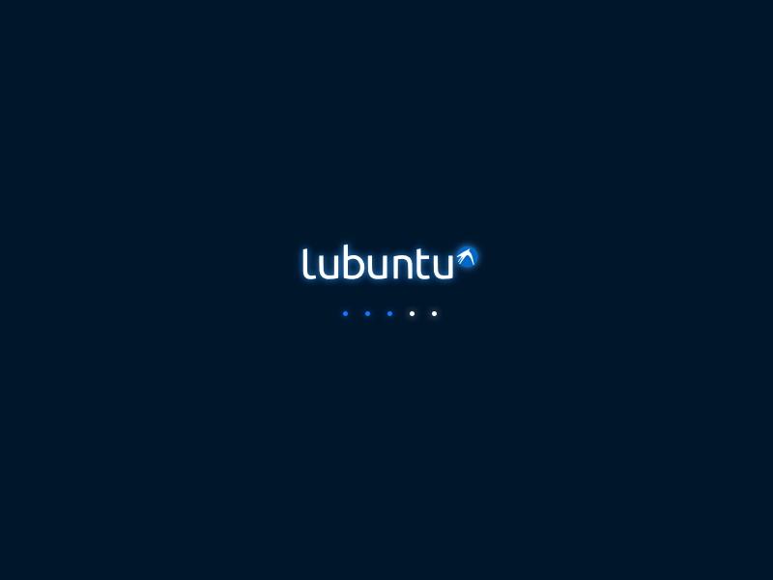

DISTRIBUTION: lubuntu

Lubuntu is a fast-lightweight Linux operating system with very simple graphical interface different from the normal ubuntu. For example, normal ubuntu uses the GNOME environment and lubuntu uses the LXDE environment. Its much less resource intensive then other environments hence why it is used in this distribution. Another part of LXDE is that it comes with light weight alternatives to common applications. The file manager, terminal, desktop panel, and theme switcher are all included with LXDE.

The biggest part of lubuntu is that it can run almost everything because it is so simple and easy to run. This is the main reason that it is used. Also, that it has the similar layout of the windows operating system. This enables an easier switch to this Linux distribution.

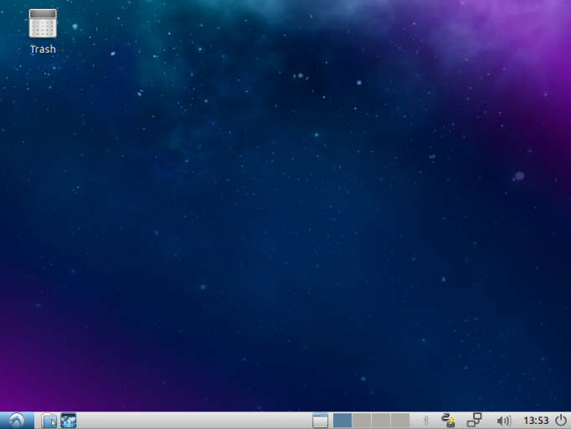 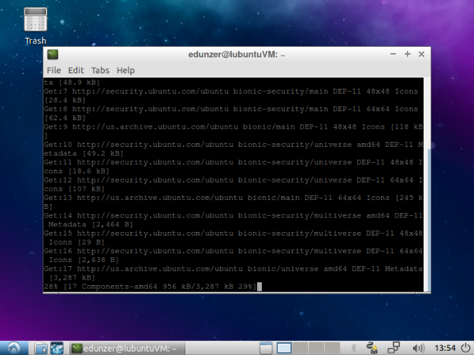

INSTALLATION PROCESS:

This is very similar to normal ubuntu. The main difference being that the installation process for lubuntu does not have such an updated installation environment as normal ubuntu does. Instead it uses a much similar graphical environment.

